Personal Details:
- ID: 10720253
- Name: Karim Zakaria Ahmed Soliman
- Surname: Saloma

Files Description:

- Source Files:

- convert.cpp: subscribe to the GPS topic of the car/obs, convert it to ENU and publish the data; if incoming GPS is (0,0,0) node publishes (nan,nan,nan).
- distServer.cpp: server node that recieves the two ENU coordinates from client and returns distance.
- customMessagePub.cpp: uses time synchronizer message filter with approximate time policy to subscribe to the data from the car & obstacle, checks if no nan values in recieved message and if so sends request to server node to get the distance. Finally, it uses the threshold parameters set by dynamic reconfigure to fill status flag and sends it in custom message with recieved distance.

- Message Files:

- Status.msg: define custom message structure used to send distance and flag.

- Service Files:

- distServ.srv: define distance service request and response.

- Config Files:

- parameters.cfg: define dynamic reconfigure parameter generator for the two thresholds.

- Launch Files:

- project_launcher.launch: launch file to set the origin point parameter and the initial value of the threshold parameters and start the four nodes in the network (2 converters , distServer and customMessagePub)

Parameters Description:

- origin_lat: origin point latitude.
- origin_long: origin point longitude.
- origin_alt: origin point altitude.
- thresh1: crash threshold (dynamically reconfigured).
- thresh2: unsafe threshold (dynamically reconfigured)

TF Tree:

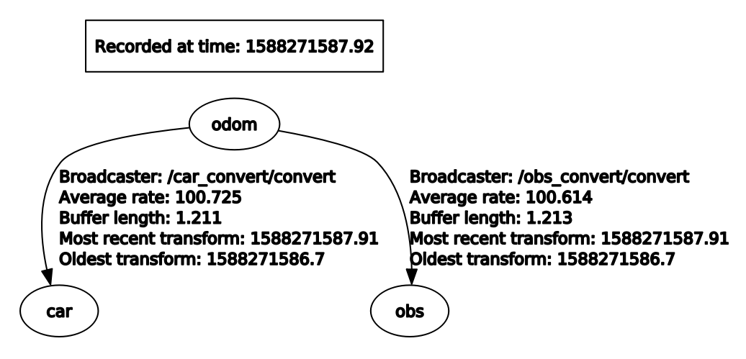
Rqt Graph:
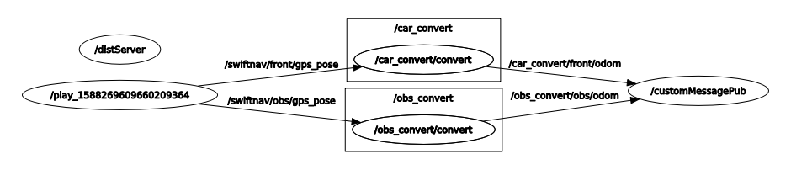
Custom Message Structure:

float64 dist
string flag

Node Run Inst. :

- $ catkin_make
- $ roscore
- $ rosbag play -l project.bag
- $ roslaunch project_1 project_launcher.launch
- $ rosrun rqt_reconfigure rqt_reconfigure (to set threshold values)
- $ rostopic echo /status (view custom status message)

Extra Info:

- args in the launch file were used to start convert node to specify which topics to subscribe in publish to for each of the two convert nodes
- nan was used to handle (0,0,0) case and is checked for in customMessagePub node if so publishes nan distance and flag=”GPS signal lost”
- dynamic reconfigure was used to set the two threshold parameters

